ACROPOLIS INSTITUTE OF TECHNOLOGY AND RESEARCH
Department of Information Technology

Synopsis
on
OpptURpath: A Personalized Opportunity Discovery and Career Guidance Platform
SIH- CODE : SIH1528
1. INTRODUCTION
1.1 Problem Context
Students and graduates today have access to a large number of educational courses, competitive examinations, jobs, skill-development programs, internships, and entrepreneurship opportunities. However, these opportunities are distributed across different websites and platforms, making it difficult for users to identify which options are relevant to their current educational qualification, skills, interests, and employment status.For example, a student studying 12th with PCM may be eligible for engineering courses and entrance examinations, while a B.Tech graduate without a job may have options such as private-sector jobs, government examinations, higher education, internships, certifications, or entrepreneurship.Existing platforms generally focus on a particular category such as jobs, courses, examinations, or career guidance. The user therefore has to search multiple sources and manually determine whether an opportunity is suitable for their current situation.The proposed project addresses this problem by developing a single platform where users can enter their current situation and receive a structured list of relevant opportunities across education, jobs, examinations, skills, and business/entrepreneurship.

1.2 Motivation & Need
The motivation for this project comes from the difficulty user’s face in understanding “What can I do next?” after reaching a particular stage of education or employment. Government and private platforms already provide useful career and employment resources. For example, India's National Career Service provides job search, internships, skill courses, career centers and counselling resources.
Similarly, research systems such as C3-IoC demonstrate how user education, skills and experience can be used to support personalized career exploration.
However, there is scope for a simpler unified platform focused on the user's current situation → possible opportunities → eligibility → next steps.The proposed system aims to reduce the effort required to search separately for different opportunities and provide users with a structured starting point for career and opportunity exploration.

2. LITERATURE SURVEY
2.1 Research Papers
Several research studies have explored personalised career guidance and recommendation systems.
- C3-IoC: A Career Guidance System for Assessing Student Skills using Machine Learning and Network Visualisation presents a system that uses education, technical skills, non-technical skills and experience to help students explore suitable IT job roles. The system combines skill profiling, a knowledge base and job-role matching.
- Recent research has also explored AI-based career recommendation systems for Indian students. CareerAstra proposes a hybrid recommendation approach combining machine learning, large language models, cognitive assessment and subject-career alignment.
- Other recent work has investigated career recommendation with skill-gap analysis, where recommendations are connected with the skills required for a particular career path.
- These studies indicate that personalised career guidance can benefit from structured user profiles, recommendation techniques and skill-based matching.
2.2 Existing Applications & Products
Existing platforms provide different types of career and employment services.
- National Career Service (NCS): Provides job search, internships, skill courses, career centres and counselling resources.
- Career guidance applications: Provide career information and recommendations based on student interests, aptitude and educational background. The Ministry of Education has also highlighted digital career-guidance initiatives providing information about career pathways, job roles, educational requirements and skills.
- Existing career recommendation systems: Research prototypes use user skills and education to match users with potential career paths.
The proposed project differs in its unified opportunity-oriented approach, where education, examinations, jobs and entrepreneurship can be represented as possible next paths from the user's current situation.

2.3 Proposed Technology and AI Integration
An AI chatbot can be integrated using Spring AI and the Gemini API to provide a conversational interface for users. The chatbot can help users understand recommended opportunities, required skills, eligibility information, and possible For the proposed implementation, the system will use Java and Spring Boot for backend development and MySQL for structured data storage . A rule-based recommendation engine will initially be used to match user profiles next steps.
The AI chatbot will act as an assistance layer rather than replacing the application's core recommendation and eligibility logic. Structured opportunity information will be maintained by the application database, while the AI component will be used primarily for natural-language interaction and explanation

2.4 Technologies Currently Used

Technologies relevant to the proposed system include:
Web application development
- Java
- SpringBoot
- HTML
- CSS
- JavaScript
- MySQL
- Rule-based recommendation
- Machine learning techniques for future enhancement
For the initial minor-project prototype, a rule-based recommendation approach can be used because it is easier to implement, explain and validate.
3. PROBLEM STATEMENT
“To develop a web-based platform that identifies and presents relevant education, employment, examination, skill-development and entrepreneurship opportunities based on a user's current educational and professional situation.”
The system should reduce the need for users to search multiple platforms by providing structured opportunity recommendations along with basic eligibility requirements and suggested next steps.

4. PROPOSED SOLUTION OVERVIEW
The proposed system, OpptURpath, is a web-based opportunity discovery platform.
The user first provides information about their current situation, such as:
- Current education level
- Stream/field
- Qualification
- Skills
- Employment status
- Interests
The system processes this information and matches it with an opportunity database.
The resulting opportunities are divided into categories such as:
Education
- Courses
- Higher studies
- Certifications
- Skill-development programs
Jobs
- Private-sector jobs
- Entry-level jobs
- Internships
- Freelancing opportunities
Examinations
- Entrance examinations
- Government examinations
- Competitive examinations
Business
- Entrepreneurship opportunities
- Small-business ideas
- Freelancing/service-based opportunities
The system can additionally display:
Opportunity → Eligibility → Required Skills → Next Step

5. OBJECTIVES
The major objectives of the proposed project are:
- To develop a centralized platform for discovering different types of opportunities based on a user's current situation.
- To provide personalised opportunity recommendations based on education, skills, interests and employment status.
- To simplify opportunity discovery by reducing the need to search separately across multiple platforms.
- To provide eligibility and requirement information for recommended opportunities.
- To provide actionable next steps such as required skills, further education, examination preparation or application direction.
- To create a scalable system that can later incorporate machine learning or AI-based recommendation techniques.

6. CONTRIBUTIONS
The key novel contributions of this project are:
- The main contribution of this project is the development of a unified opportunity discovery system rather than a platform limited to only jobs or only educational courses.
- The proposed system contributes:
- A single interface for multiple opportunity categories.
- Situation-based opportunity discovery.
- Basic eligibility matching.
- Structured presentation of opportunities.
- Career-path exploration from the user's current position.
- A modular architecture that can be extended with machine learning in the future.

Example of the proposed contribution
Instead of:

Student → Search Google → Search Courses
↓
Search Exams
↓
Search Jobs
↓
Compare Eligibility
the proposed system aims for:
Student
↓
Current Situation
↓
OpportunityPath
↓
│ Courses │ Exams │ Jobs │Business │

7. THEORETICAL ANALYSIS
7.1 Block Diagram
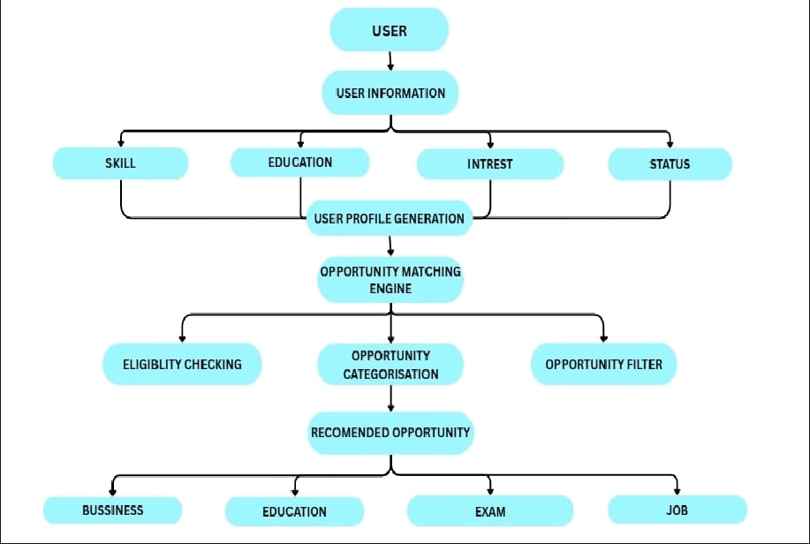

7.2 Hardware / Software Requirements

Software Requirements:
Minimum requirements:
- Computer/Laptop
- Minimum 4 GB RAM
- Dual-core processor or better
- Keyboard and mouse
- Internet connection for accessing online opportunity information, if required
For development and demonstration, a standard laptop/desktop is sufficient.
Software Requirements
Component | Technology
Operating System | Windows / Linux
Frontend | HTML, CSS, JavaScript
Backend | Python
Framework | Flask
Database | SQLite
Template Engine | Jinja2
Development Environment | VS Code / similar IDE
Browser | Chrome / Firefox / Edge

8. APPLICATIONS
The OpptURpath system has broad applicability across multiple domains:
1. Student Career Guidance: Students can explore courses, entrance examinations and career paths based on their academic background.
2. Graduate Opportunity Discovery: Graduates can discover jobs, examinations, higher studies and skill-development opportunities.
3. Skill Development: Users can identify skills they need to acquire before pursuing a particular opportunity.
4. Employment Guidance: Job seekers can explore relevant employment opportunities based on their qualifications and skills.
5. Competitive Examination Discovery: Users can identify examinations for which they may be eligible.
6. Entrepreneurship: Users can explore business and self-employment opportunities as alternatives to conventional employment.
7. Educational Institutions: Colleges and schools could potentially use the platform as an additional career-guidance resource.

REFERENCES
- José-García, A., Sneyd, A., Melro, A. et al., “C3-IoC: A Career Guidance System for Assessing Student Skills using Machine Learning and Network Visualisation,”International Journal of Artificial Intelligence in Education, 2023.
- SreeVastha, T. V., Raja Subramanian, R., Thisyanth, P., VenuBabu, T., Srikanth, P., “CareerAstra: An AI-Powered Hybrid Recommendation System for Career Guidance of Indian Students,” 2026.
- Xu, X. &Gao, H., “A knowledge graph-integrated recommendation method for college student career planning,”Discover Artificial Intelligence, 2026.
- National Career Service (NCS), Ministry of Labour& Employment, Government of India.
- Ministry of Education, Government of India, resources on career pathways and career guidance.

GIT-HUB repository
https://github.com/vatsalnagarr/minorproject_01

Guided By: Group Members:
Prof. _____________ Vatsal Nagar 0827IT241146
Yash Pal 0827IT241152
Virani Trivedi 0827IT241150
External Guide: Rishabh singh jadoun 0827IT241109
No.)
__________________

Project Incharge
Prof. _______________

